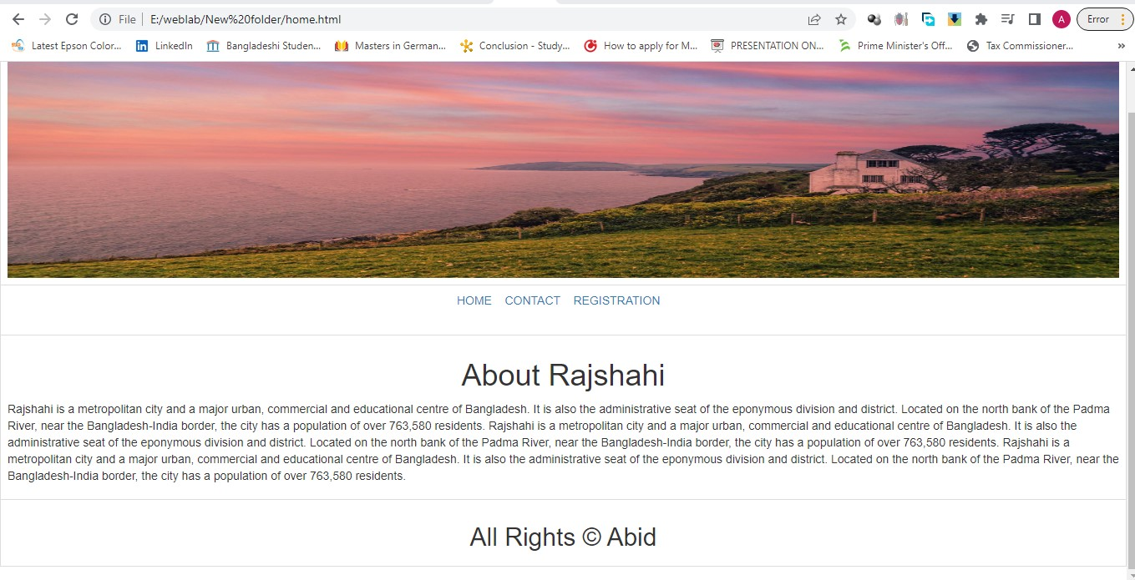

home.html

<!DOCTYPE html>

<html lang="en">

<head>

<meta charset="UTF-8">

<meta http-equiv="X-UA-Compatible" content="IE=edge">

<meta name="viewport" content="width=device-width, initial-scale=1.0">

<title></title>

<link rel="stylesheet" href="https://cdn.jsdelivr.net/npm/bootstrap@3.3.7/dist/css/bootstrap.min.css" integrity="sha384-BVYiiSIFeK1dGmJRAkycuHAHRg32OmUcww7on3RYdg4Va+PmSTsz/K68vbdEjh4u" crossorigin="anonymous">

<link rel="stylesheet" href="https://cdn.jsdelivr.net/npm/bootstrap@3.3.7/dist/css/bootstrap-theme.min.css" integrity="sha384-rHyoN1iRsVXV4nD0JutlnGaslCJuC7uwjduW9SVrLvRYooPp2bWYgmgJQIXwl/Sp" crossorigin="anonymous">

</head>

<body>

<table class="table table-bordered" height="100%" width="100%">

<tr height="50%" width="100%">

<td><img src="1.jpg" class="img-fluid" height="300" width="100%"></td>

</tr>

<tr class="bg-light" height="60" width="auto">

<td class="text-center">

<a class="text-primary" href="home.html">HOME</a>&nbsp;&nbsp;&nbsp;

<a class="text-primary" href="contact.html">CONTACT</a>&nbsp;&nbsp;&nbsp;

<a class="text-primary" href="registration.html">REGISTRATION</a>&nbsp;&nbsp;&nbsp;

</td>

</tr>

<tr>

<td class="bg-light">

<h1 class="text-center">About Rajshahi</h1>

<p>

Rajshahi is a metropolitan city and a major urban, commercial and educational centre of Bangladesh. It is also the administrative seat of the eponymous division and district. Located on the north bank of the Padma River, near the Bangladesh-India border, the city has a population of over 763,580 residents. Rajshahi is a metropolitan city and a major urban, commercial and educational centre of Bangladesh. It is also the administrative seat of the eponymous division and district. Located on the north bank of the Padma River, near the Bangladesh-India border, the city has a population of over 763,580 residents. Rajshahi is a metropolitan city and a major urban, commercial and educational centre of Bangladesh. It is also the administrative seat of the eponymous division and district. Located on the north bank of the Padma River, near the Bangladesh-India border, the city has a population of over 763,580 residents.

</p>

</td>

</tr>

<tr class="bg-light">

<td>

<h2 class="text-center" >All Rights &copy Abid</h2>

</td>

</tr>

</table>

<script src="https://cdn.jsdelivr.net/npm/bootstrap@3.3.7/dist/js/bootstrap.min.js" integrity="sha384-Tc5IQib027qvyjSMfHjOMaLkfuWVxZxUPnCJA7l2mCWNIpG9mGCD8wGNIcPD7Txa" crossorigin="anonymous"></script>

</body>

</html>

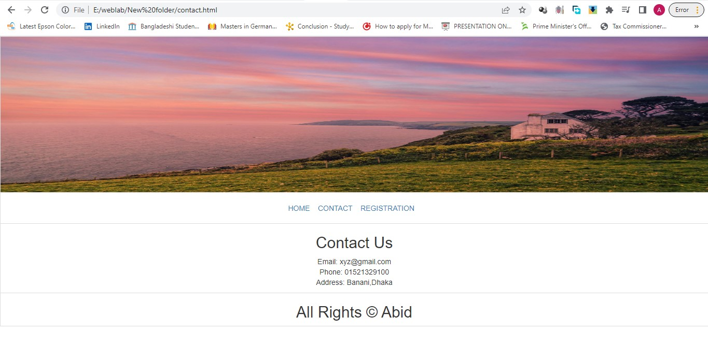

contact.html

<!DOCTYPE html>

<html lang="en">

<head>

<meta charset="UTF-8">

<meta http-equiv="X-UA-Compatible" content="IE=edge">

<meta name="viewport" content="width=device-width, initial-scale=1.0">

<title></title>

<link rel="stylesheet" href="https://cdn.jsdelivr.net/npm/bootstrap@3.3.7/dist/css/bootstrap.min.css" integrity="sha384-BVYiiSIFeK1dGmJRAkycuHAHRg32OmUcww7on3RYdg4Va+PmSTsz/K68vbdEjh4u" crossorigin="anonymous">

<link rel="stylesheet" href="https://cdn.jsdelivr.net/npm/bootstrap@3.3.7/dist/css/bootstrap-theme.min.css" integrity="sha384-rHyoN1iRsVXV4nD0JutlnGaslCJuC7uwjduW9SVrLvRYooPp2bWYgmgJQIXwl/Sp" crossorigin="anonymous">

</head>

<body>

<table class="table-bordered" height="100%" width="100%">

<tr height="50%" width="100%">

<td><img src="1.jpg" class="img-fluid" height="300" width="100%"></td>

</tr>

<tr class="bg-light" height="60" width="auto">

<td class="text-center">

<a class="text-primary" href="home.html">HOME</a>&nbsp;&nbsp;&nbsp;

<a class="text-primary" href="contact.html">CONTACT</a>&nbsp;&nbsp;&nbsp;

<a class="text-primary" href="registration.html">REGISTRATION</a>&nbsp;&nbsp;&nbsp;

</td>

</tr>

<tr>

<td class="bg-light" >

<h2 class="text-center">Contact Us</h2>

<p class="text-center">Email: xyz@gmail.com<br>

Phone: 01521329100<br>

Address: Banani,Dhaka<br> </p>

</td>

</tr>

<tr class="bg-light">

<td>

<h2 class="text-center" >All Rights &copy Abid</h2>

</td>

</tr>

</table>

<script src="https://cdn.jsdelivr.net/npm/bootstrap@3.3.7/dist/js/bootstrap.min.js" integrity="sha384-Tc5IQib027qvyjSMfHjOMaLkfuWVxZxUPnCJA7l2mCWNIpG9mGCD8wGNIcPD7Txa" crossorigin="anonymous"></script>

</body>

</html>

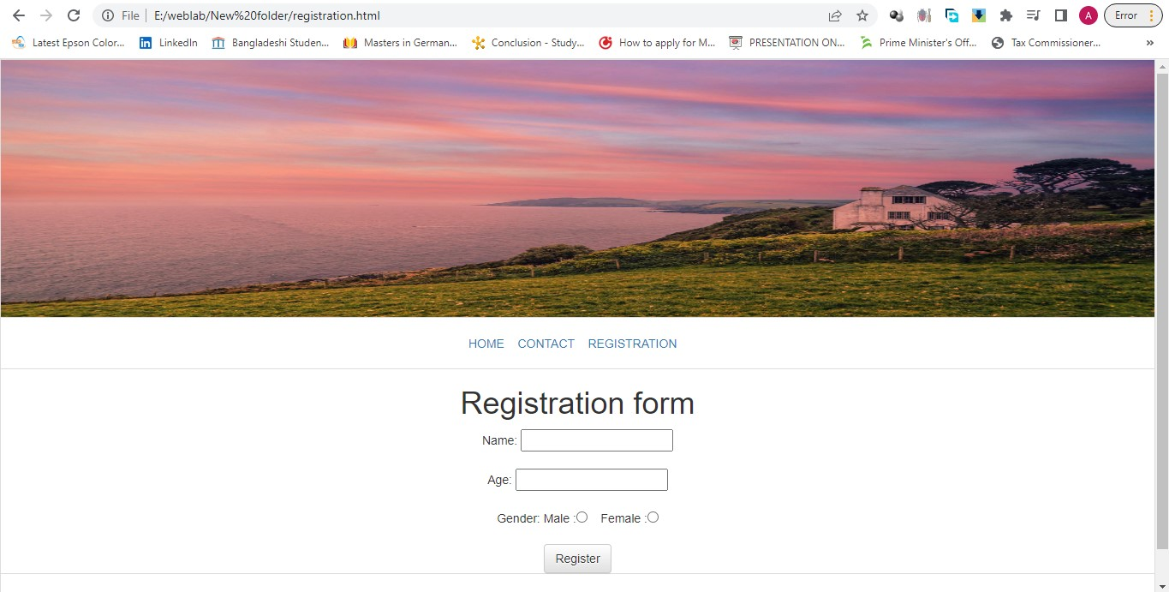

registration.html

<!DOCTYPE html>

<html lang="en">

<head>

<meta charset="UTF-8">

<meta http-equiv="X-UA-Compatible" content="IE=edge">

<meta name="viewport" content="width=device-width, initial-scale=1.0">

<title></title>

<link rel="stylesheet" href="https://cdn.jsdelivr.net/npm/bootstrap@3.3.7/dist/css/bootstrap.min.css" integrity="sha384-BVYiiSIFeK1dGmJRAkycuHAHRg32OmUcww7on3RYdg4Va+PmSTsz/K68vbdEjh4u" crossorigin="anonymous">

<link rel="stylesheet" href="https://cdn.jsdelivr.net/npm/bootstrap@3.3.7/dist/css/bootstrap-theme.min.css" integrity="sha384-rHyoN1iRsVXV4nD0JutlnGaslCJuC7uwjduW9SVrLvRYooPp2bWYgmgJQIXwl/Sp" crossorigin="anonymous">

</head>

<body>

<table class="table-bordered" height="100%" width="100%">

<tr height="50%" width="100%">

<td><img src="1.jpg" class="img-fluid" height="300" width="100%"></td>

</tr>

<tr class="bg-light" height="60" width="auto">

<td class="text-center">

<a class="text-primary" href="home.html">HOME</a>&nbsp;&nbsp;&nbsp;

<a class="text-primary" href="contact.html">CONTACT</a>&nbsp;&nbsp;&nbsp;

<a class="text-primary" href="registration.html">REGISTRATION</a>&nbsp;&nbsp;&nbsp;

</td>

</tr>

<tr>

<td class="bg-light text-center">

<h1 class="text-center" >Registration form </h1>

<form name="admission" action="#">

Name: <input type="text" name="sname"><br><br>

Age: <input type="number" name="sage"><br><br>

Gender: Male :<input type="radio" name="gender" value="Male"> &nbsp;&nbsp;

Female :<input type="radio" name="gender" value="Female"><br><br>

<input class="btn btn-default" type="submit" name="submit" value="Register">

</form>

</td>

</tr>

<tr class="bg-light">

<td>

<h2 class="text-center" >All Rights &copy Abid</h2>

</td>

</tr>

</table>

<script src="https://cdn.jsdelivr.net/npm/bootstrap@3.3.7/dist/js/bootstrap.min.js" integrity="sha384-Tc5IQib027qvyjSMfHjOMaLkfuWVxZxUPnCJA7l2mCWNIpG9mGCD8wGNIcPD7Txa" crossorigin="anonymous"></script>

</body>

</html>

**Bootstrap :**

There are two ways to start using Bootstrap on web site.

* Download Bootstrap from getbootstrap.com
* Include Bootstrap from a Content Delivery Network (CDN)

### Here for adding Bootstrap we use CDN. After adding the Bootstrap's CSS and JS files to our HTML page, we can begin to develop any responsive site or application with the Bootstrap framework. Bootstrap offers different classes for design a html file.